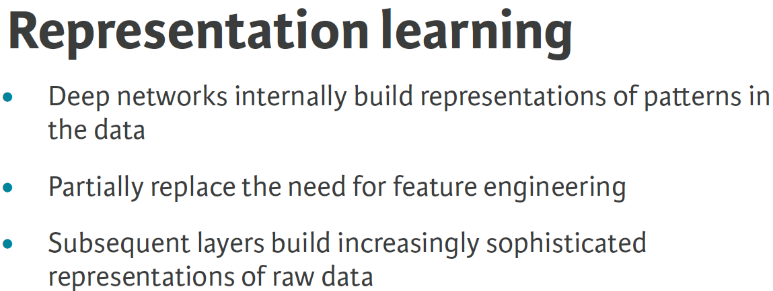

**Backpropagation Algorithm**

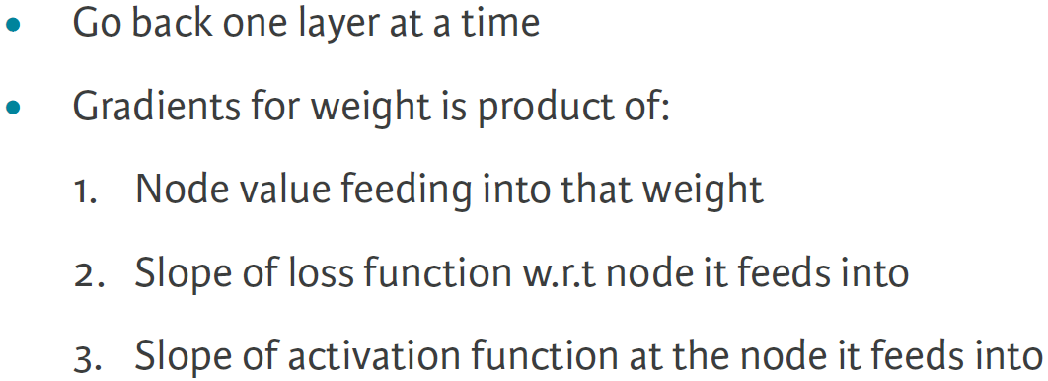

**Model Specification**

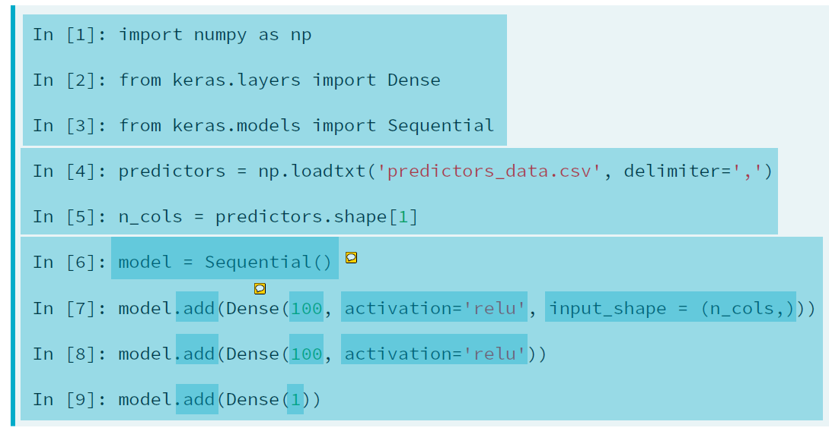

**Compiling and Fitting a Model**

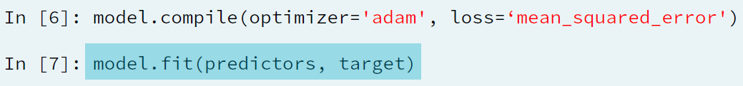

**Classification**

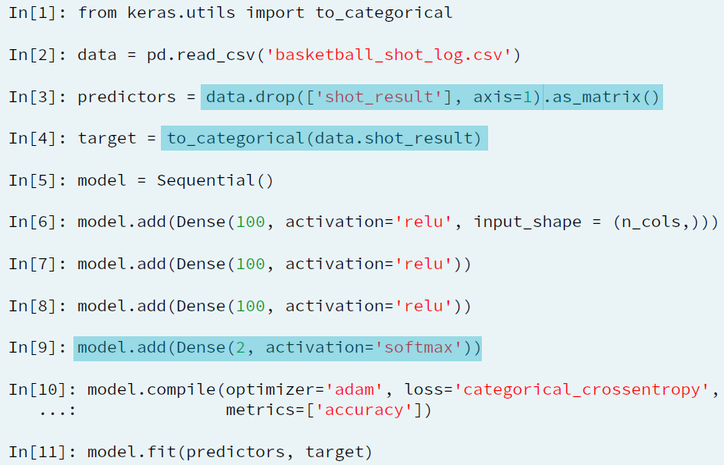

**Making Predictions**

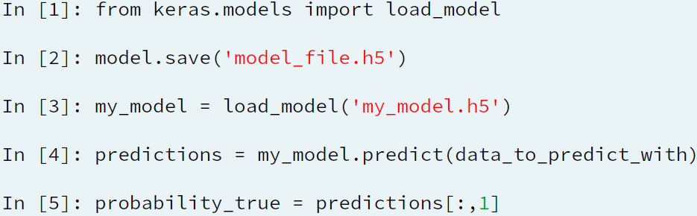

**Vanishing Gradient**

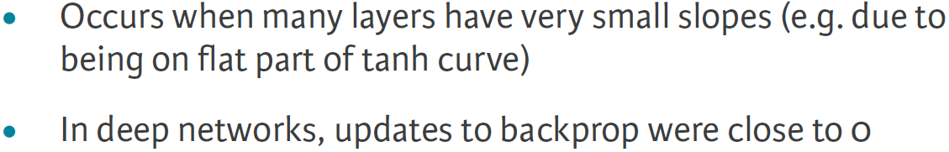

**Dying Neuron Problem – ReLU**

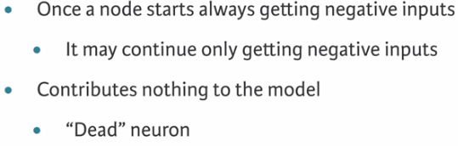

**Early Stopping**

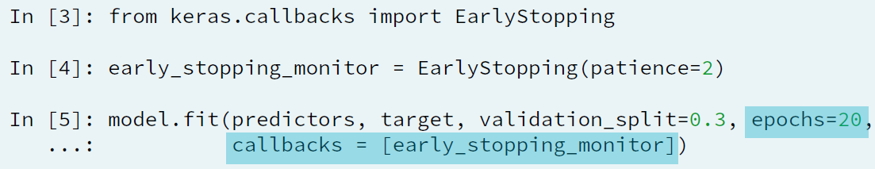

**Model Capacity**

